Міністерство освіти і науки України Західноукраїнський Національний Університет Факультет комп’ютерних інформаційних технологій
Кафедра Кібербезпеки

Комплексне практичне індивідуальне завдання З дисциплін «Основи програмування»
Тема: «Робота з файлами. Обробка текстової інформації»

Виконав:

Перевірив:

Тернопіль 2022

Варіант 1:
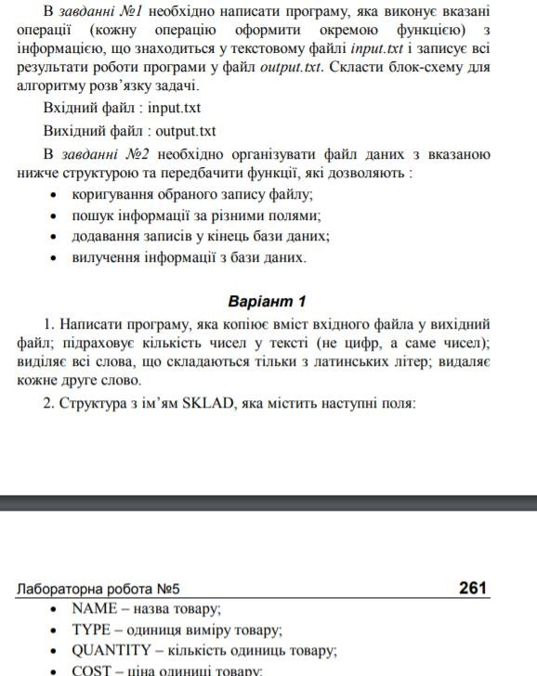

Робота програми:

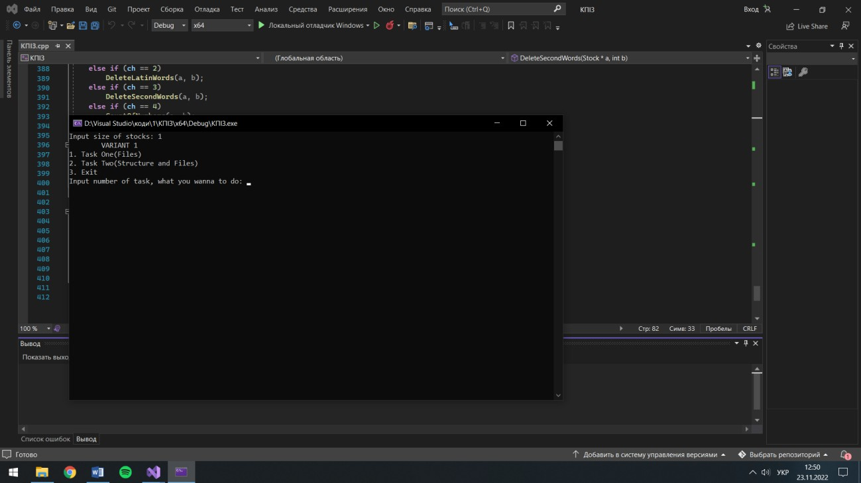

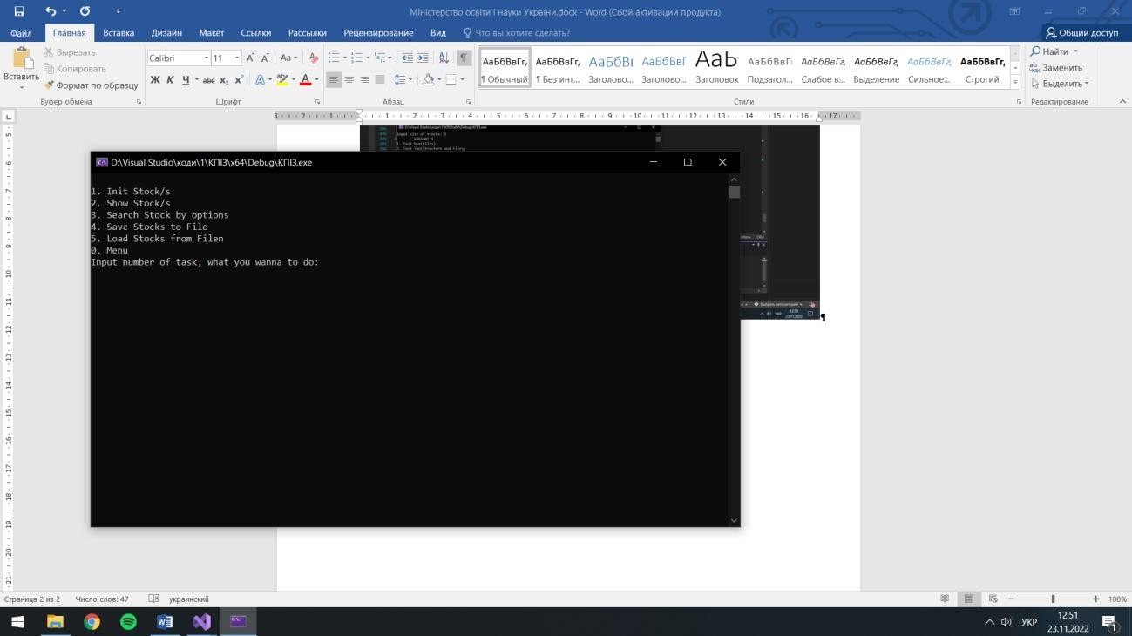

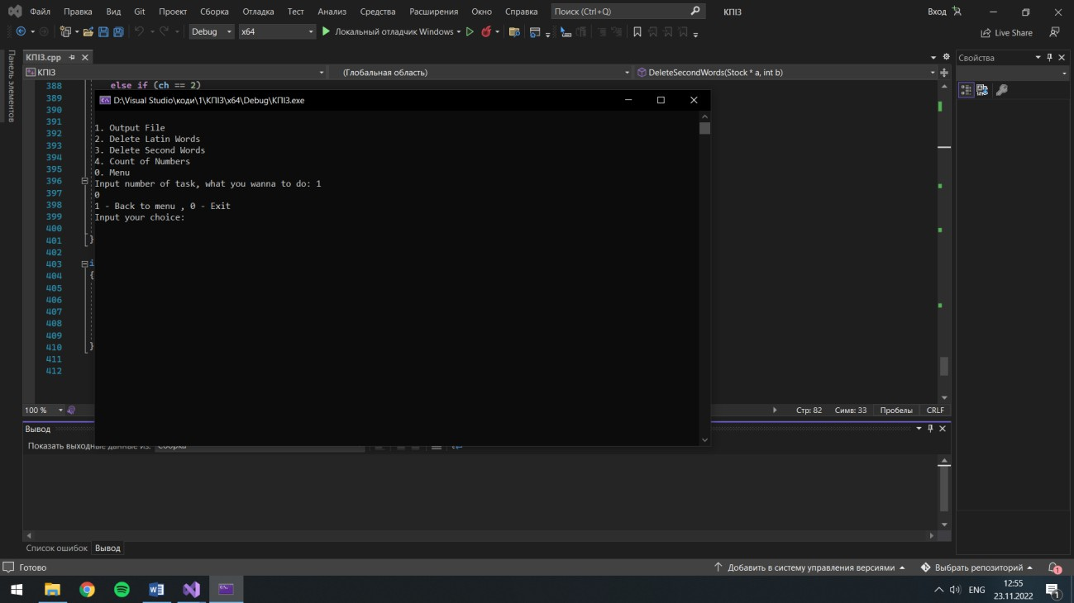

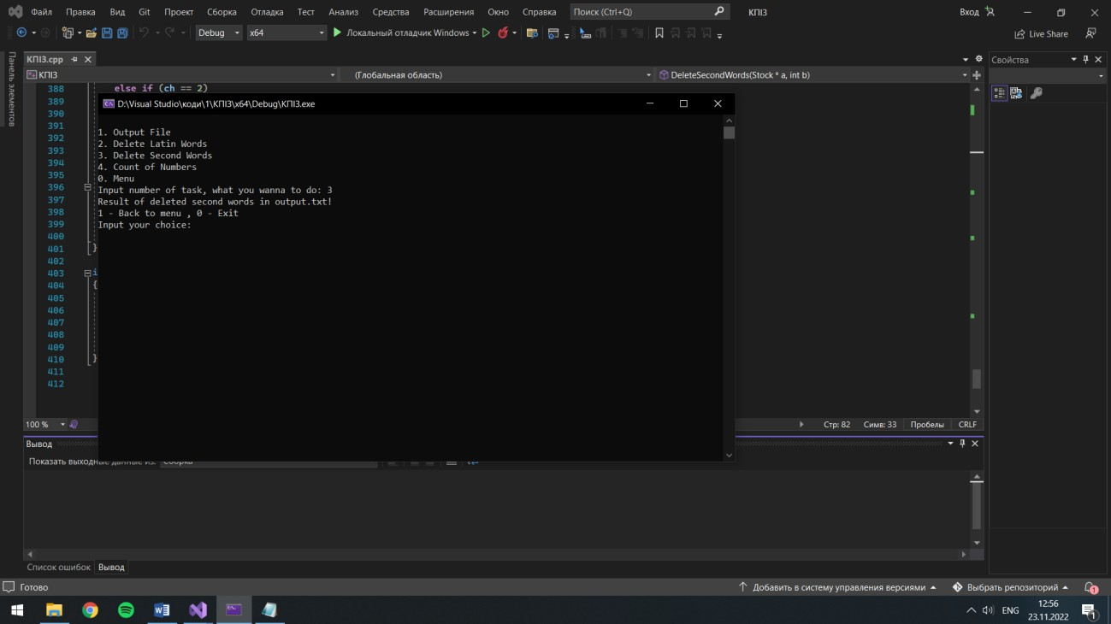

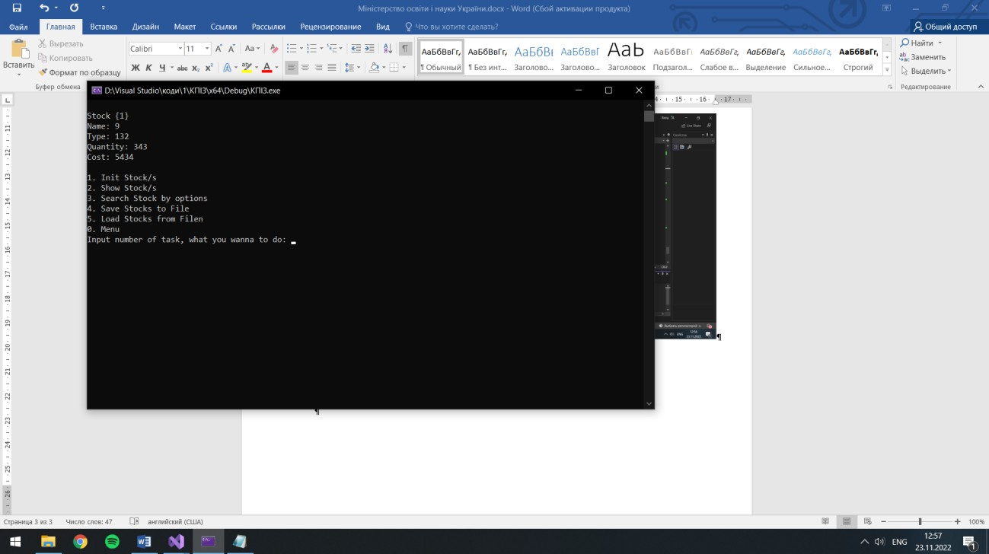

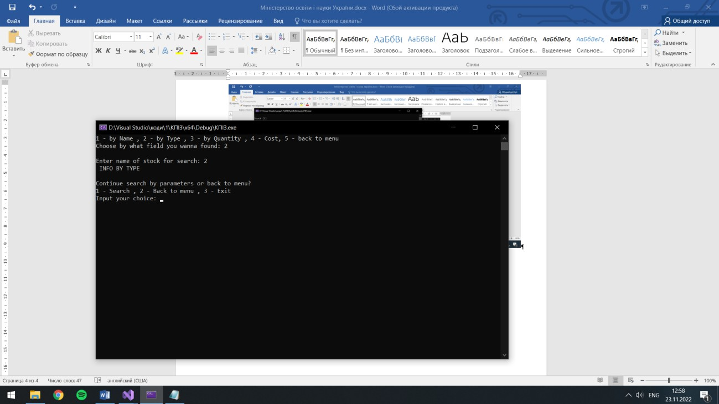

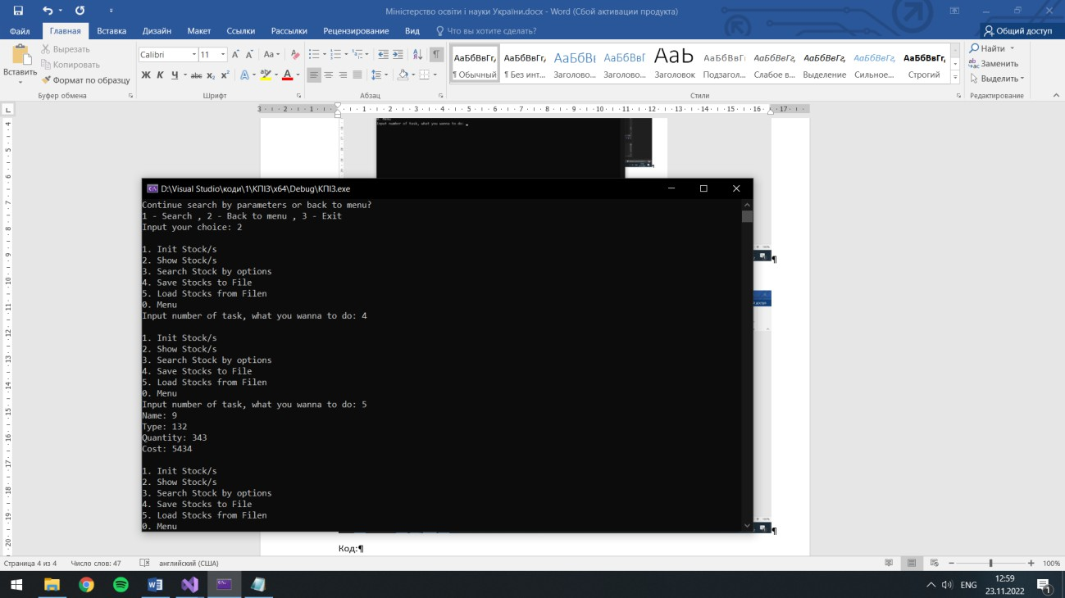

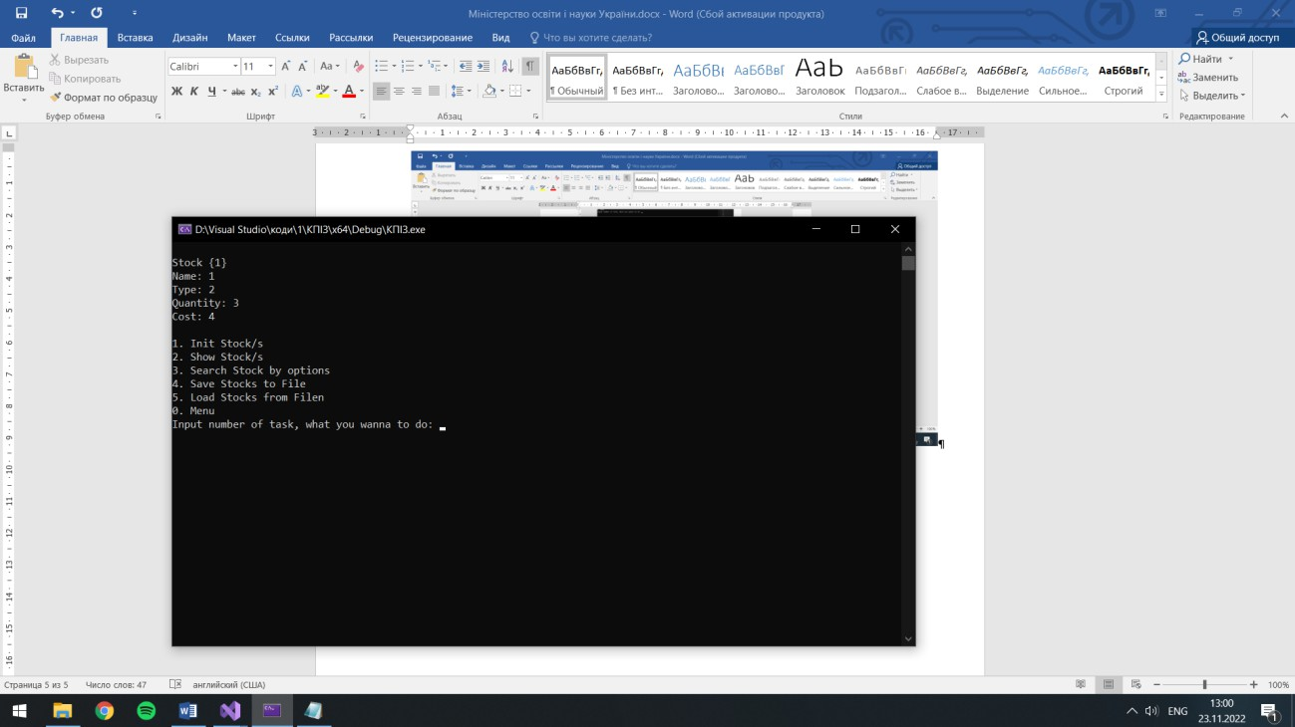

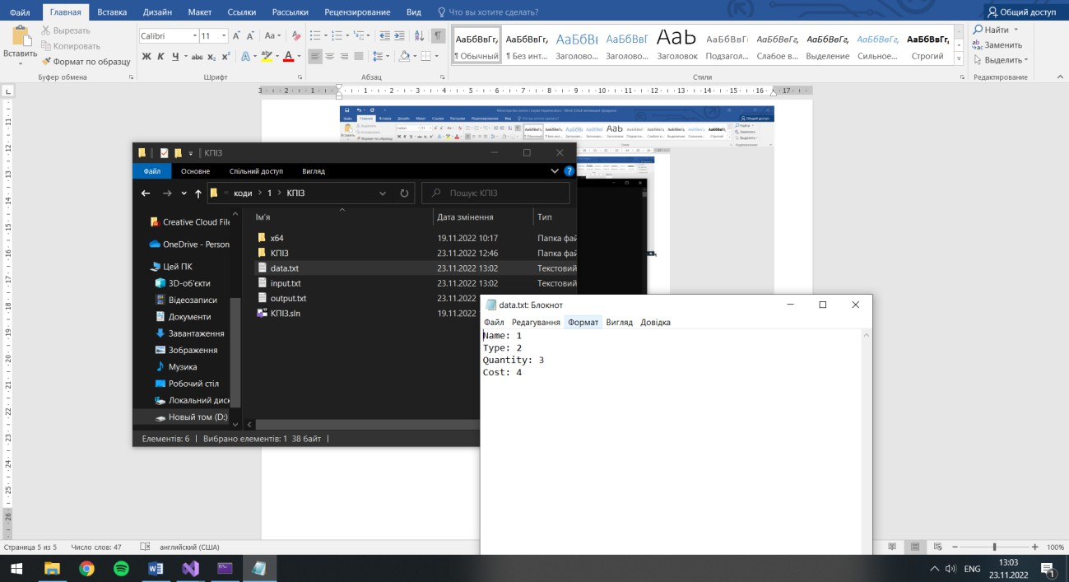

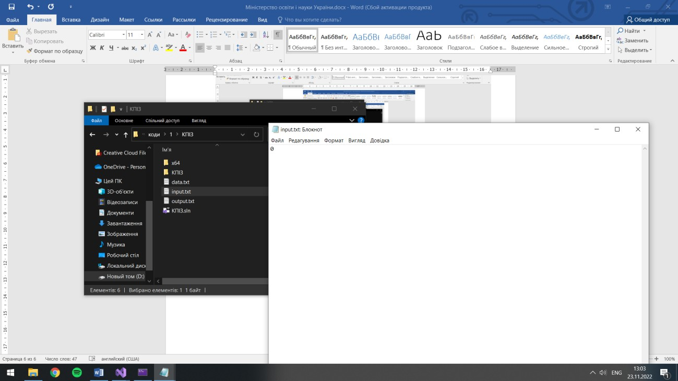

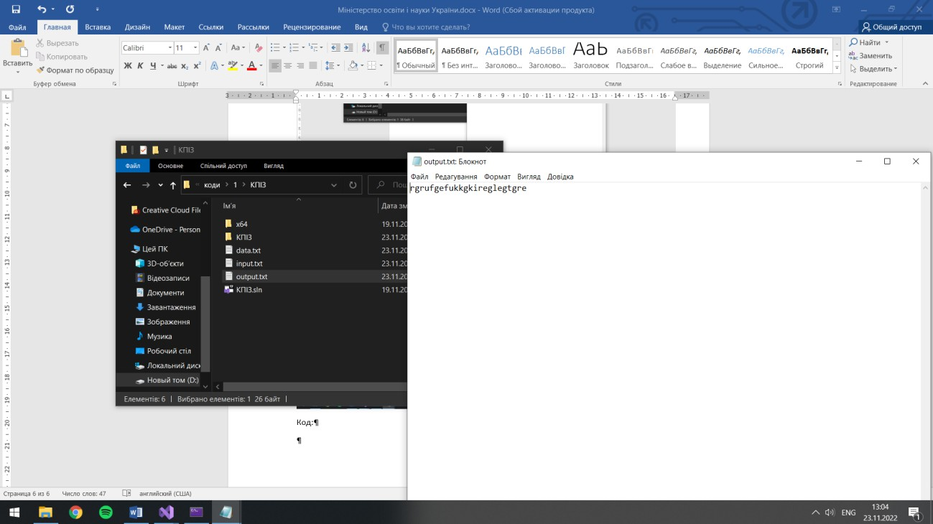

Код:
#define _CRT_SECURE_NO_WARNINGS #include <iostream>
#include "ctime" #include "cstring" #include <fstream> #include <string> #include <cstdlib> #include <cctype> #include <iterator> #include <algorithm> #include <sstream> #include <vector> #include <stdio.h> #include <stdlib.h> using namespace std;
#define clean system("CLS")

/* Глобальні зміни */
const char* PATH = "data.txt";
/* Прототипи */ struct Stock;
void Menu(Stock* a, int b);
void TaskStructure(Stock* a, int b); void TaskFiles(Stock* a, int b);

/* Завдання 1 - файли */
void OutputFile(Stock* a, int b)
{
string line;
ifstream in("input.txt"); if (in.is_open())
{
while (getline(in, line)) cout << line << endl;
}
in.close();
ifstream out("output.txt"); if (out.is_open())
while (getline(out, line)) cout << line << endl;
out.close(); int ch = 0;
cout << "1 - Back to menu , 0 - Exit" << endl; cout << "Input your choice: "; cin >> ch;
if (ch == 1)

TaskFiles(a, b); else if (ch == 0)
exit(0);
}
void DeleteLatinWords(Stock* a, int b)
{
ifstream file("input.txt"); string str, s;
while (getline(file, str))
{
str += " ";
for (int i = 0; i < str.size(); i++) if (!(isalpha(str[i])))
s += str[i];
}
str = s; file.close();
ofstream infile("output.txt"); if (infile.is_open())
infile << "Sentence without latin symbols: " << str << endl; infile.close();
cout << "Result sentence without latin symbols output.txt!" << endl; int ch = 0;
cout << "1 - Back to menu , 0 - Exit" << endl; cout << "Input your choice: "; cin >> ch;
if (ch == 1) TaskFiles(a, b);
else if (ch == 0) exit(0);

}
void DeleteSecondWords(Stock* a, int b)
{
ifstream file("input.txt"); vector <string> temp; string str;
getline(file, str); istringstream splitting(str); while (splitting >> str)
{
temp.push_back(str); splitting >> str;
}
file.close();
ofstream infile("output.txt"); if (infile.is_open())
copy(temp.begin(), temp.end(), ostream_iterator<string>(infile, " ")); infile.close();
int ch = 0;
cout << "Result of deleted second words in output.txt!" << endl; cout << "1 - Back to menu , 0 - Exit" << endl;
cout << "Input your choice: "; cin >> ch; if (ch == 1)
TaskFiles(a, b); else if (ch == 0)
exit(0);
}
void CountOfNumbers(Stock* a, int b)
{

ifstream file("input.txt"); int count = 0;
string str, s;
while (getline(file, str))
{
str += ' ';
for (int i = 0; i < str.length(); i++)
{
if (isdigit(str[i])) s += str[i];
if (!(isdigit(str[i])))
{
if (s != "") count++;
s = "";
}
}
}
file.close();
ofstream infile("output.txt");
cout << "Results counts of numbers in output.txt!" << endl; if (infile.is_open())
infile << count << endl; infile.close();
int ch = 0;
cout << "Result of deleted second words in output.txt!" << endl; cout << "1 - Back to menu , 0 - Exit" << endl;
cout << "Input your choice: "; cin >> ch; if (ch == 1)

TaskFiles(a, b); else if (ch == 0)
exit(0);
}

/* Завдання 2 - структури */ struct Stock
{
char name[100]; int type;
int quantity; double cost;
};
void byName(Stock* a, int b); void byType(Stock* a, int b); void byQuantity(Stock* a, int b); void byCost(Stock* a, int b);

/* FUNCTIONAL */
void Initiallization(Stock* a, int b)
{
for (int i = 0; i < b; i++)
{
cout << "\n";
cout << "Stock {" << i + 1 << "}" << endl; cout << "Input name of stock: ";
cin >> a[i].name;
cout << "Input type of stock: "; cin >> a[i].type;

cout << "Input quantity of stock: "; cin >> a[i].quantity;
cout << "Input cost of stock: "; cin >> a[i].cost;
}
}
void Show(Stock* a, int b)
{
for (int i = 0; i < b; i++)
{
cout << "\n";
cout << "Stock {" << i + 1 << "}" << endl; cout << "Name: " << a[i].name << endl; cout << "Type: " << a[i].type << endl;
cout << "Quantity: " << a[i].quantity << endl; cout << "Cost: " << a[i].cost << endl;
}
}
void Find(Stock* a, int b)
{
clean;
int ch = 0;
cout << "1 - by Name , 2 - by Type , 3 - by Quantity , 4 - Cost, 5 - back to menu" << endl;
cout << "Choose by what field you wanna found: "; cin >> ch; if (ch == 1)
byName(a, b); else if (ch == 2)
byType(a, b);

else if (ch == 3) byQuantity(a, b);
else if (ch == 4) byCost(a, b); else if (ch == 5)
TaskStructure(a, b); else
{
clean; Find(a, b);
}
}

/* Пошук файлів */
void byName(Stock* a, int b)
{
char buf[50];
cout << "\nEnter name of stock for search: "; cin >> buf;
cout << " INFO BY NAME " << endl; for (int i = 0; i < b; i++)
if (strcmp(a[i].name, buf) == 0)
cout << "\nName: " << a[i].name << "\nType: " << a[i].type << "\nQuantity: " << a[i].quantity << "\nCost:" << a[i].cost << endl;
int ch = 0;
cout << "Continue search by parameters or back to menu? " << endl; cout << "1 - Search , 2 - Back to menu , 3 - Exit" << endl;
cout << "Input your choice: "; cin >> ch; if (ch == 1)

Find(a, b); else if (ch == 2)
TaskStructure(a, b); else if (ch == 3)
exit(0);
}
void byType(Stock* a, int b)
{
int buf;
cout << "\nEnter name of stock for search: "; cin >> buf;
cout << " INFO BY TYPE " << endl; for (int i = 0; i < b; i++)
if (a[i].type == buf)
cout << "\nType: " << a[i].type << "\nName: " << a[i].name << "\nQuantity: " << a[i].quantity << "\nCost:" << a[i].cost << endl;
int ch = 0;
cout << "\nContinue search by parameters or back to menu? " << endl; cout << "1 - Search , 2 - Back to menu , 3 - Exit" << endl;
cout << "Input your choice: "; cin >> ch; if (ch == 1)
Find(a, b); else if (ch == 2)
TaskStructure(a, b); else if (ch == 3)
exit(0);
}
void byQuantity(Stock* a, int b)
{

int buf;
cout << "\nEnter name of stock for search: "; cin >> buf;
cout << " INFO BY QUANTITY " << endl;
for (int i = 0; i < b; i++) if (a[i].quantity == buf)
cout << "\nQuantity: " << a[i].quantity << "\nName: " << a[i].name << "\nType: " << a[i].type << "\nCost:" << a[i].cost << endl;
int ch = 0;
cout << "Continue search by parameters or back to menu? " << endl; cout << "1 - Search , 2 - Back to menu , 3 - Exit" << endl;
cout << "Input your choice: "; cin >> ch; if (ch == 1)
Find(a, b); else if (ch == 2)
TaskStructure(a, b); else if (ch == 3)
exit(0);
}
void byCost(Stock* a, int b)
{
double buf;
cout << "\nEnter name of stock for search: "; cin >> buf;
cout << " INFO BY COST " << endl; for (int i = 0; i < b; i++)
if (a[i].cost == buf)
cout << "\nCost:" << a[i].cost << "\nName: " << a[i].name << "\nType: "
<< a[i].type << "\nQuantity: " << a[i].quantity << endl;

int ch = 0;
cout << "Continue search by parameters or back to menu? " << endl; cout << "1 - Search , 2 - Back to menu , 3 - Exit" << endl;
cout << "Input your choice: "; cin >> ch; if (ch == 1)
Find(a, b); else if (ch == 2)
TaskStructure(a, b); else if (ch == 3)
exit(0);
}
void SaveToFile(Stock* a, int b)
{
ofstream fo(PATH, ios::binary); for (unsigned i = 0; i < b; i++)
{
fo.write((char*)&a[i].name, sizeof(a[i].name));
fo.write((char*)&a[i].type, sizeof(a[i].type)); fo.write((char*)&a[i].quantity, sizeof(a[i].quantity)); fo.write((char*)&a[i].cost, sizeof(a[i].cost));
}
fo.close();
}
void LoadFromFile(Stock* a, int b)
{
Stock* ptrstock = new Stock[b]; ifstream fr(PATH, ios::binary); for (unsigned i = 0; i < b; i++)
{

fr.read((char*)&ptrstock[i].name, sizeof(a[i].name)); fr.read((char*)&ptrstock[i].type, sizeof(a[i].type)); fr.read((char*)&ptrstock[i].quantity, sizeof(a[i].quantity)); fr.read((char*)&ptrstock[i].cost, sizeof(a[i].cost));
}
fr.close();
for (unsigned i = 0; i < b; i++)
cout << "Name: " << ptrstock[i].name << "\nType: " << ptrstock[i].type << "\nQuantity: " << ptrstock[i].quantity << "\nCost: " << ptrstock[i].cost << '\n';
delete[] ptrstock;
}

/* Меню */
void Menu(Stock* a, int b)
{
int ch = 0;
cout << "\tVARIANT 1" << endl;
cout << "1. Task One(Files)\n2. Task Two(Structure and Files)\n3. Exit" << endl;
cout << "Input number of task, what you wanna to do: "; cin >> ch;
if (ch == 1)
{
clean; TaskFiles(a, b);
}
else if (ch == 2)
{
clean;

TaskStructure(a, b);
}
else if (ch == 0) exit(0);
else
{
clean; Menu(a, b);
}
}
void TaskStructure(Stock* a, int b)
{
int ch = 0;
cout << "\n1. Init Stock/s\n2. Show Stock/s\n3. Search Stock by options\n4.
Save Stocks to File\n5. Load Stocks from Filen\n0. Menu" << endl; cout << "Input number of task, what you wanna to do: ";
cin >> ch; if (ch == 1)
{
Initiallization(a, b); clean; TaskStructure(a, b);
}
else if (ch == 2)
{
clean; Show(a, b);
TaskStructure(a, b);
}

else if (ch == 3)
{
clean; Find(a, b);
TaskStructure(a, b);
}
else if (ch == 4)
{
SaveToFile(a, b); TaskStructure(a, b);
}
else if (ch == 5)
{
LoadFromFile(a, b); TaskStructure(a, b);
}
else if (ch == 0)
{
clean; Menu(a, b);
}
}
void TaskFiles(Stock* a, int b)
{
clean;
int ch = 0;
cout << "\n1. Output File\n2. Delete Latin Words\n3. Delete Second Words\n4.
Count of Numbers\n0. Menu" << endl;
cout << "Input number of task, what you wanna to do: ";

cin >> ch; if (ch == 1)
OutputFile(a, b); else if (ch == 2)
DeleteLatinWords(a, b); else if (ch == 3)
DeleteSecondWords(a, b); else if (ch == 4)
CountOfNumbers(a, b); else if (ch == 0)
Menu(a, b); else
{
clean; TaskFiles(a, b);
}
}

int main()
{
int size = 0;
cout << "Input size of stocks: "; cin >> size; Stock* stock = new Stock[size]; Menu(stock, size);
delete[]stock;
}
Висновок: в цій лабораторній роботі я оволодів практичними навичками використання структур та масивів структур, навчився складати програми для виконання операцій з полями структур, навчився використовувати динамічне виділення пам’яті.

